City of Clearwater

Main Library - Council Chambers
100 N. Osceola Avenue
Clearwater, FL 33755

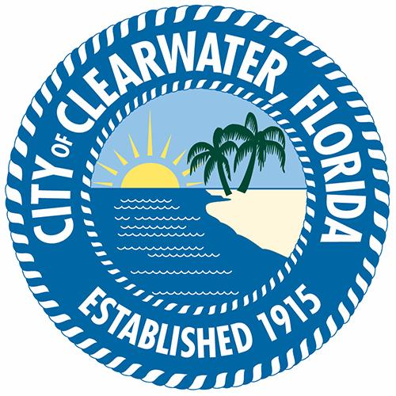

Meeting Minutes

Tuesday, October 22, 2024

6:30 PM

Main Library - Council Chambers

Parks and Recreation Board
Roll Call

Present 5 - Vice Chair Jason Hood, Board Member Martin Armstrong, Board
Member Kelly S. Kelly, Board Member Stephanie Sisti, Board Member Candace Gardner, and Board Member Angelica Lonesome

Absent 3 -, Board Member Mark Rodriguez, and Board Member Angela Tisdale

Also Present – Art Kader – Parks & Recreation Director and Danielle DeBois –City Clerk Specialist

1. Call To Order

The meeting was called to order at 6:30 p.m.

2. Approval of Minutes

2.1 Approval of the July 23, 2024, Parks and Recreation Board Meeting Minutes

Board Member Jason Hood moved to approve the July 23, 2024 Parks
and Recreation Board Meeting minutes as submitted in written
summation. The motion was duly seconded and carried unanimously.

3. Citizens to be Heard Regarding Items Not on the Agenda: None

4. New Business Items

4.1 Discussion of the Parks and Recreation October Project Update Report

Parks and Recreation Director Art Kader said some projects were
affected by Hurricanes Helene and Milton, and that they are currently
assessing and working to mitigate damages. Kader said the Parks and Recreation department is hopeful for minimal timeline variance in project completions.

4.2 Discussion of Damages Sustained to the Parks from Hurricane Helene

Mr. Kader said that multiple parks throughout the city were damaged in
the hurricanes and are currently in varying degrees of recovery. Mr.
Kader provided a status update on several park locations and said status information is also on the city website.

4.3 Discuss Keeping Restrooms Open During the Day at Parks that Currently
Unlock Only for Reservations

Mr. Kader said that multiple park restrooms have been closed with
exceptions for reserved periods since 2008. In response to a question
Mr. Kader said that the total restrooms closed due to budgetary restrictions is at
least six.

5. Old Business Items

5.1 Discuss Installing a Short Sidewalk at Forest Run Park from the Parking Lot to
the Right-of-Way Sidewalk

Mr. Kader said they are waiting on state permitting due to the proximity of
a state road and the slope of the ground to begin pouring the sidewalk.

6. Director's Report

Mr. Kader said he appreciates the work and dedication of the employees who have tirelessly put in the overtime to restore the city parks after the damages done by the hurricanes.

7. Board Members to be Heard

Board members expressed their gratitude to employees for the efforts and dedication they put into recovery.
.

8. Adjourn

The meeting was adjourned at 7:05 p.m.

___________________________________
Attest: Chair, Parks & Recreation Advisory Board

___________________________________
City Clerk Specialist

